Practical 7

Logistic Regression and Decision Tree

* Build a logistic regression model to predict a binary outcome.
* Evaluate the model's performance using classification metrics (e.g., accuracy, precision, recall).
* Construct a decision tree model and interpret the decision rules for classification

Code:

# Import Required Libraries import numpy as np import pandas as pd

import matplotlib.pyplot as plt import seaborn as sns

from sklearn.model_selection import train_test_split from sklearn.preprocessing import StandardScaler from sklearn.linear_model import LogisticRegression from sklearn.metrics import (

accuracy_score, precision_score, recall_score, f1_score, confusion_matrix, classification_report, roc_curve, auc

)

# Step 1: Create Sample Dataset (Binary Classification) np.random.seed(42)

data = {

'Age': np.random.randint(20, 60, 100),

'Salary': np.random.randint(30000, 100000, 100),

'Purchased': np.random.choice([0, 1], size=100) # 0 = No Purchase, 1 = Purchased

}

df = pd.DataFrame(data) print("\nDataset Sample:\n", df.head())

# Step 2: Split Data into Training & Testing Sets X = df[['Age', 'Salary']]

y = df['Purchased']

X_train, X_test, y_train, y_test = train_test_split(X, y, test_size=0.2, random_state=42)

# Step 3: Standardize Features (for better performance) scaler = StandardScaler()

X_train_scaled = scaler.fit_transform(X_train) X_test_scaled = scaler.transform(X_test)

# Step 4: Train Logistic Regression Model log_model = LogisticRegression() log_model.fit(X_train_scaled, y_train)

# Step 5: Make Predictions

y_pred = log_model.predict(X_test_scaled)

# Step 6: Compute Classification Metrics accuracy = accuracy_score(y_test, y_pred) precision = precision_score(y_test, y_pred) recall = recall_score(y_test, y_pred)

f1 = f1_score(y_test, y_pred)

print("\n🔹 Classification Metrics:") print(f"Accuracy: {accuracy:.4f}") print(f"Precision: {precision:.4f}") print(f"Recall: {recall:.4f}")

print(f"F1-Score: {f1:.4f}")

# Step 7: Confusion Matrix

conf_matrix = confusion_matrix(y_test, y_pred) plt.figure(figsize=(6, 4))

sns.heatmap(conf_matrix, annot=True, fmt='d', cmap="Blues", xticklabels=['No Purchase', 'Purchase'], yticklabels=['No Purchase', 'Purchase'])

plt.xlabel("Predicted") plt.ylabel("Actual") plt.title("Confusion Matrix") plt.show()

# Step 8: ROC Curve & AUC Score

y_prob = log_model.predict_proba(X_test_scaled)[:, 1] fpr, tpr, _ = roc_curve(y_test, y_prob)

roc_auc = auc(fpr, tpr)

plt.figure(figsize=(6, 4))

plt.plot(fpr, tpr, label=f"AUC = {roc_auc:.2f}", color='blue') plt.plot([0, 1], [0, 1], linestyle='--', color='grey') # Diagonal Line plt.xlabel("False Positive Rate")

plt.ylabel("True Positive Rate") plt.title("ROC Curve")

plt.legend() plt.show()

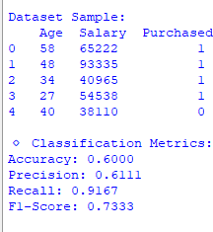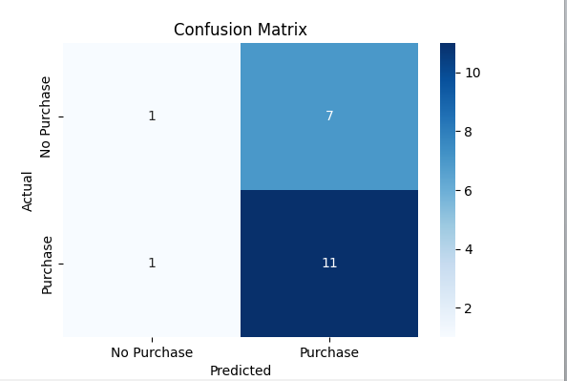

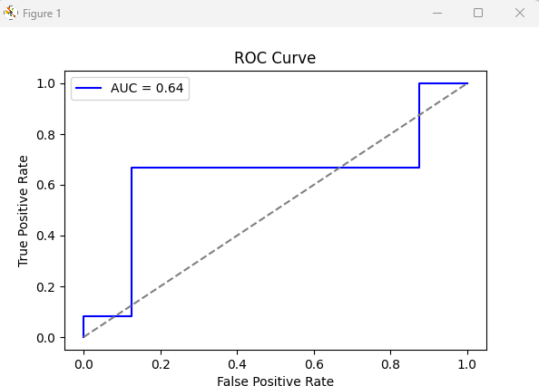

**Construct a decision tree model and interpret the decision rules for classification Code:**

# Import Required Libraries import numpy as np import pandas as pd

import matplotlib.pyplot as plt import seaborn as sns

from sklearn.model_selection import train_test_split from sklearn.preprocessing import StandardScaler

from sklearn.tree import DecisionTreeClassifier, plot_tree

from sklearn.metrics import accuracy_score, classification_report, confusion_matrix

# Step 1: Create Sample Dataset (Binary Classification) np.random.seed(42)

data = {

'Age': np.random.randint(20, 60, 100),

'Salary': np.random.randint(30000, 100000, 100),

'Purchased': np.random.choice([0, 1], size=100) # 0 = No Purchase, 1 = Purchased

}

df = pd.DataFrame(data) print("\nDataset Sample:\n", df.head())

# Step 2: Split Data into Training & Testing Sets X = df[['Age', 'Salary']]

y = df['Purchased']

X_train, X_test, y_train, y_test = train_test_split(X, y, test_size=0.2, random_state=42)

# Step 3: Train Decision Tree Classifier

dt_model = DecisionTreeClassifier(criterion='gini', max_depth=3, random_state=42) dt_model.fit(X_train, y_train)

# Step 4: Make Predictions

y_pred = dt_model.predict(X_test)

# Step 5: Compute Model Accuracy accuracy = accuracy_score(y_test, y_pred)

print(f"\n🔹 Decision Tree Accuracy: {accuracy:.4f}")

# Step 6: Display Confusion Matrix

conf_matrix = confusion_matrix(y_test, y_pred) plt.figure(figsize=(6, 4))

sns.heatmap(conf_matrix, annot=True, fmt='d', cmap="Blues", xticklabels=['No Purchase', 'Purchase'], yticklabels=['No Purchase', 'Purchase'])

plt.xlabel("Predicted") plt.ylabel("Actual") plt.title("Confusion Matrix") plt.show()

# Step 7: Display Classification Report print("\n Classification Report:") print(classification_report(y_test, y_pred))

# Step 8: Visualize the Decision Tree

plt.figure(figsize=(12, 6))

plot_tree(dt_model, feature_names=['Age', 'Salary'], class_names=['No Purchase', 'Purchase'], filled=True, rounded=True)

plt.title("Decision Tree Visualization") plt.show()

# Step 9: Interpret Decision Rules from sklearn.tree import export_text

tree_rules = export_text(dt_model, feature_names=['Age', 'Salary']) print("\n🔹 Decision Rules:\n", tree_rules)

